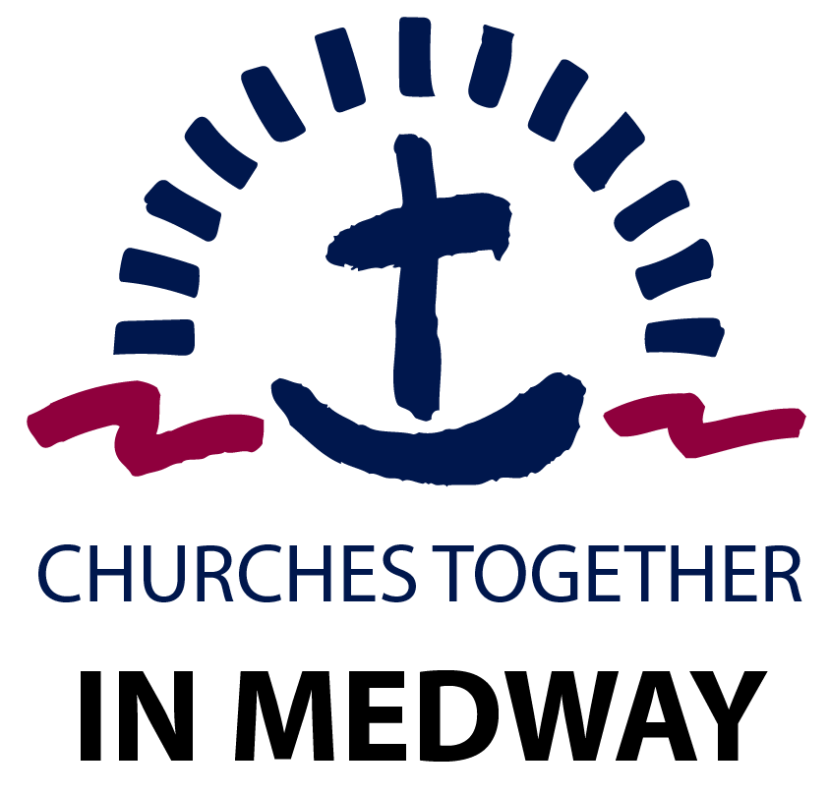

https://medwaychurch.co.uk/ Registered charity number 1080486
Membership and Subscription Form 2023 Please tick (√) the appropriate box
We would like to be a Member of CTIM and enclose a Membership fee * of £________
We would like to be kept up to date but are not able to pay a subscription.
Please make cheques payable to CTIM, or by bank transfer to Natwest Acct. 55302955. Sort code: 600509 (contact treasurer@medwaychurch.co.uk when payment/donation is made thank you)
Church/Organisation Details

Minister/Leader: ______________________________________________________________

Church Name: ______________________________________________________________
Email: ______________________________________________________________
Website: ______________________________________________________________
Phone Number: ______________________________________________________________

Church address ______________________________________________________________

______________________________________________________________
Delivery Address
______________________________________________________________

______________________________________________________________

Please note that the only details which will appear in the Directory are the name of the Church/Organisation and website details. If there is no website, please supply an email address.

CTIM Contact: (Please complete this section if you would like future CTIM communications sent to a different contact than that which is listed above)

Name: ______________________________________________________________

Email: ______________________________________________________________

Suggested Minimum Subscriptions:

- Churches with under 50 members £25
- Churches with between 50 and 100 members £35
- Churches with over 100 members £45
- Other Christian organisations £20
- Donation to CTIM (towards the budget 2023) £_____

Please return this fully completed Membership & Subscription Form, along with your subscription to:
Administrator, CTIM, C/O RCCG Victorious Family Parish,
Abundant Life Arena, Dock Road, Chatham. ME4 4TX
or alternatively email the completed form to admin@medwaychurch.co.uk

Would you consider using the form below to set up a standing order mandate to ensure you/your church or organisation could keep supporting the work of CTIM in joint mission projects please?

Your financial support helped us to:

- Organise the Saints Alive joint church event on the 31st October every year.
- Provide financial support for the Christmas Connect Joint Carol Outreach event in December.
- Send financial support to encourage the churches in Ukraine which were severely affected by the war with Russia.
- Cover all our insurance/administrative costs to keep our various meetings during the year and social media platforms active.
- Your support helps CTIM stand as a strong ecumenical voice across Medway towns.
- Your contributions and donations ensure we can meet our budgetary obligations during the year and much more.

No member of the executive team gets paid for the work they do; we are grateful for the time they put in.

STANDING ORDER MANDATE –CTIM ACCOUNT

To the Manager of _________________________________________Bank

Branch ___________________________________________________

Address __________________________________________________
____________________________________________________
Please pay NATWEST Bank Plc, for the credit of Churches Together in Medway

Account Number: 55302955
Sort Code: 60-05-09

Name of Church/Organisation/Individual/ Ref:

£__________________________
Amount in figure Amount in words

From ____ /____ / ____ and every _____ day of the week / month until further notice.

__________________________ ____________________________
Authorised Signatory Authorised Signatory

The name in which my account is held: (Yours)

My account number is __________________________________

Sort Code ___________________________________

________________________________ _________________
Authorised Signature (S) Date

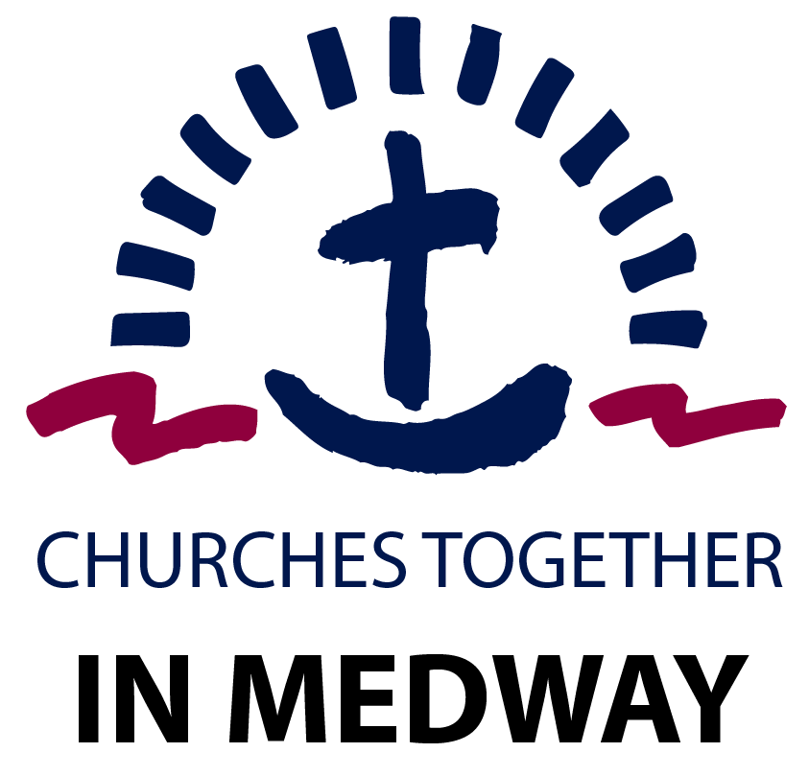

CTIM exists to serve the churches of Medway. Churches and Christian organisations across the area are invited to sign up as members of CTIM and we also have the option for individuals to sign up as associate members. Here are some of the main reasons we encourage you to consider becoming a member of Churches Together in Medway today:

Churches Together in Medway is:

An Expression of God’s Heart
Choosing to come together across our different denominations, traditions and backgrounds is an active sign of the unity that Christ desires for His Church. Churches Together in Medway exists as the broadest expression of Christian unity across Medway and is seeking to grow in the number and breadth of churches that we represent.

A United Voice
As the Church seeks to engage with local authority, police, and other statutory and voluntary organisations there are times when having a single and united voice makes this engagement more meaningful and fruitful. Your membership helps CTIM to represent churches more authentically and accurately across Medway.

A Network of Friendship
Churches Together in Medway provides opportunities for Christian leaders to gather for mutual support, networking, and prayer. This predominantly takes place through our regular Ministers and Leaders’ Breakfast and Prayer events.

A Shared Resource
CTIM seeks to resource the local church by running events and activities that unite local Christians in prayer, worship, and action to see the kingdom of God advance in our communities and beyond. Your subscription fees and your active participation and engagement help to make events such as Saints Alive, Christmas Connect and the Summer Picnic and Prayer Event possible.

A Hub of Information
The CTIM website, monthly newsletter and social media presence are together increasingly functioning as ways of sharing important information about Christian events and initiatives that may be of benefit to the wider church. We are also currently developing our local directory to ensure that the Churches Together in Medway website holds the most comprehensive and up to date details about churches and Christian organisations across Medway.

Able To Do More Together
We celebrate all the wonderful and faithful ministry and mission taking place in churches across Medway, but we recognise that at times we are called to join together. Whether in social action, mission and evangelism, worship or prayer we can often do more and experience a special blessing when we work and dwell together. Please join us as we continue to work for the coming of the Kingdom of God here in Medway.

Churches Together in Medway operates as a registered charity (Charity Number 1080486) and is overseen by an Executive Committee* (trustees) representing churches in the area.

If you have any questions about membership or require any further information about Churches Together in Medway please visit www.medwaychurch.co.uk or email us at admin@medwaychurch.co.uk

*Executive Committee: Stephen Bello (Chair), Chris Gill (Vice Chair), Pam Tolhurst (Secretary)
Duncan Cawte, Karen Willing, Edward Wright, Jill Wright, Luke Bacon.

