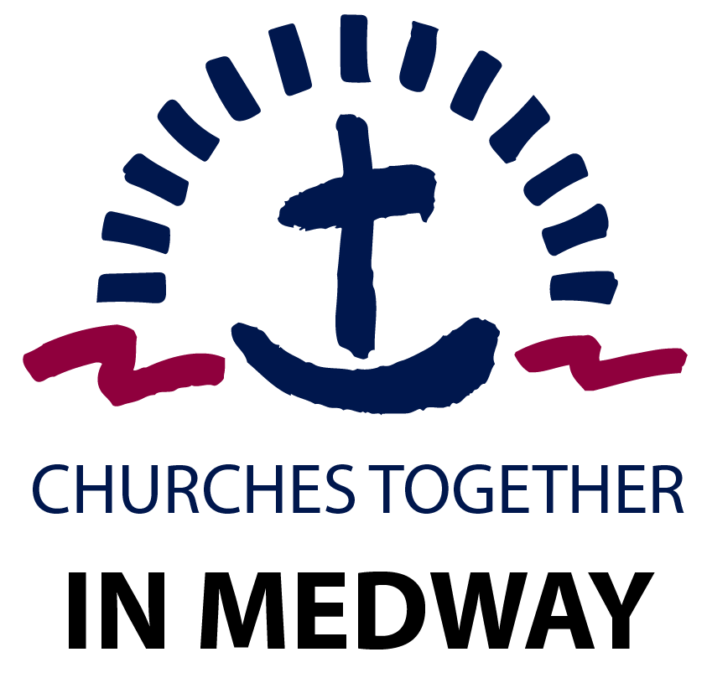

https://medwaychurch.co.uk/ Registered charity number 1080486

Membership and Subscription Form 2023 Please tick (√) the appropriate box
We would like to be a Member of CTIM and enclose a Membership fee * of £________
We would like to be kept up to date but are not able to pay a subscription.

Please make cheques payable to CTIM, or by bank transfer to Natwest Acct. 55302955. Sort code: 600509 (contact treasurer@medwaychurch.co.uk when payment/donation is made thank you)
Church/Organisation Details

Minister/Leader: ______________________________________________________________

Church Name: ______________________________________________________________
Email: ______________________________________________________________
Website: ______________________________________________________________
Phone Number: ______________________________________________________________

Church address ______________________________________________________________

______________________________________________________________
Delivery Address
______________________________________________________________

______________________________________________________________

Please note that the only details which will appear in the Directory are the name of the Church/Organisation and website details. If there is no website, please supply an email address.

CTIM Contact: (Please complete this section if you would like future CTIM communications sent to a different contact than that which is listed above)

Name: ______________________________________________________________

Email: ______________________________________________________________

Suggested Minimum Subscriptions:

- Churches with under 50 members £25
- Churches with between 50 and 100 members £35
- Churches with over 100 members £45
- Other Christian organisations £20
- Donation to CTIM (towards the budget 2023) £_____

Please return this fully completed Membership & Subscription Form, along with your subscription to:
Administrator, CTIM, C/O RCCG Victorious Family Parish,
Abundant Life Arena, Dock Road, Chatham. ME4 4TX
or alternatively email the completed form to admin@medwaychurch.co.uk

